https://x.com/asxyzp/status/1990883345178460187?t=eG_lZUA7PXJAr-UHHTQ0aQ&s=19
To back up this post with data

We got https://www.data.gov.in/resource/total-agriculture-land-holders-total

According to this if we assume the area in acres(as its not mentioned there)
Calculated the ratio by dividing the area with number of land holders
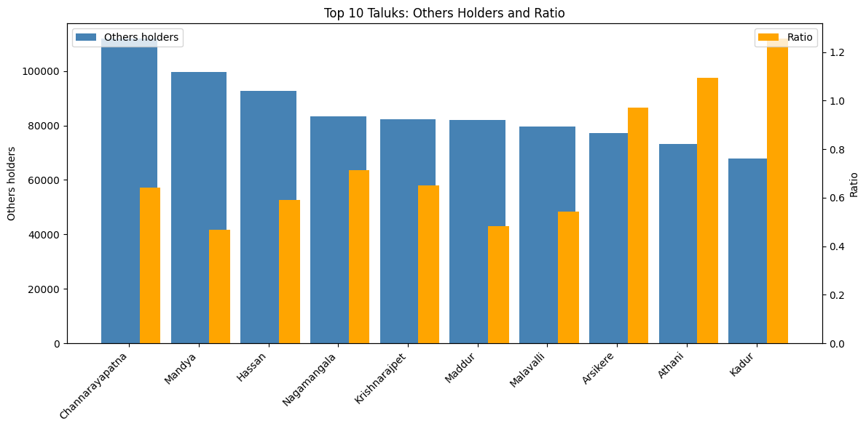

The number of people who got an area under 1.5 acres are 4,404,862 from the total area holders 7,167,460.
The total ratio of area is 444.9221 and according to the number of holders under 1.5 acres the total ratio of area is 115.884241223

4,404,862 + 2,762,598 = 7167460
61% of people

115.884241223 + 329.037858777 = 444.9221
26% of area

That means 61% of people are holding only 26% of the area according to this data.

Odisha Land Distribution Data Example:​ https://rotiodisha.nic.in/files/Project%20Report_16th%20batch/OLR_Ceiling%20Surplus/Smruti%20Rekha%20Das_16th%20Batch.pdf
In the study village, 160,636.803 acres of surplus land was distributed since inception to 143,485 beneficiaries:
- SC Beneficiaries: 51,317.562 acres to 49,083 persons (average 1.05 acres/person)
- ST Beneficiaries: 66,462.146 acres to 53,208 persons (average 1.25 acres/person)
- Percentage of total distributed: 70% (proportional to SC/ST population)
This demonstrates institutional commitment to SC/ST beneficiaries at the implementation level, even when overall land distribution remained limited.
OTHER EXPLORED LINKS :
https://thelawbrigade.com/property-law/agriculture-land-and-ceiling-laws-in-india-an-overview/

